Texhong Has Sold Its Only XUAR Factory

In 2016, Texhong invested in the development of a cotton spinning plant in northern XUAR to be closer to the main cotton-growing region. The factory in XUAR was called Xinjiang Tianmian Foundation Co., Ltd. (“ Tianmian Factory”, named Xinjiang Texhong Foundation Co., Ltd. before August, 2020). As concern increased during 2020-21 over cotton products from XUAR, Texhong decided to sell its Tianmian factory. Texhong signed a contract to sell the Tianmian factory on September 27, 2021, to an unaffiliated company. The sale closed on November 5, 2021. Texhong no longer has any production in XUAR.

The annexes below are the related documents for the transaction: Annex I: Texhong 2020 Organization Chart in Public Annual Report
Texhong Western Holdings Limited is the holding company of Xinjiang Tianmian Foundation Textile Co., Ltd, the legal entity of Texhong factory in XUAR. Texhong Western Holdings Limited is shown on the top of the leftist column of the organization chart, right under the Texhong Textile Group Limited. The link below are the whole Texhong annual report, and the organization chart is on page 5 of the report.
https://www1.hkexnews.hk/listedco/listconews/sehk/2021/0326/2021032600718.pdf

Annex II: Certificate of Great Triumph Investments Limited of Changing Name on 2021-6-10 Texhong changed the name of Texhong Western Holdings Limited to Great Triumph Investments Limited when Texhong decided to sell the factories in XUAR in June, 2021.

Annex III: Texhong’s Public Notice for the Disposal of XUAR Factory on 2021-11-5
The transaction for the disposal of Great Triumph Investments Limited was officially announced on 2021/11/5.

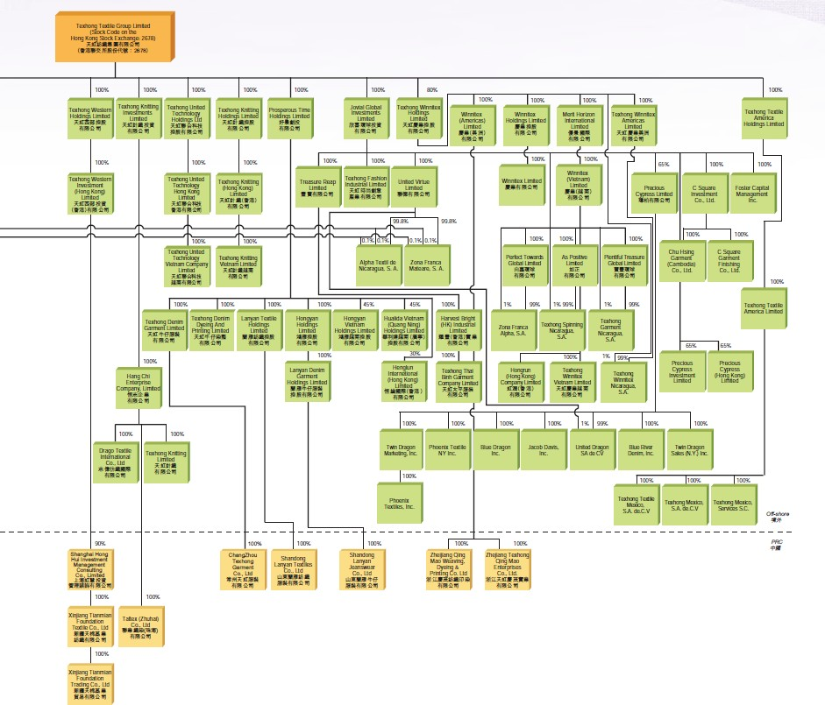Annex I: Texhong 2020 Organization Chart in Public Annual Report

Annex II: Certificate of Great Triumph Investments Limited for Changing of Name on 2021- 6-10

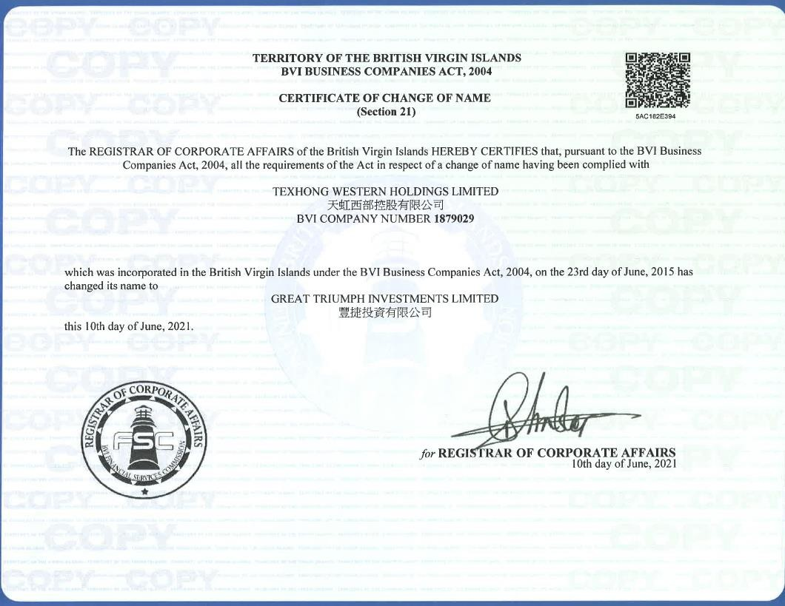

Annex III: Texhong’s Public Notice for sale of XUAR Factories on 2021-11-5

Hong Kong Exchanges and Clearing Limited and The Stock Exchange of Hong Kong Limited take no responsibility for the contents of this announcement, make no representation as to its accuracy or completeness and expressly disclaim any liability whatsoever for any loss howsoever arising from or in reliance upon the whole or any part of the contents of this announcement.

Texhong Textile Group Limited
天虹紡織集團有限公司
(incorporated in the Cayman Islands with limited liability)

(Stock Code: 2678)
- DISCLOSEABLE TRANSACTION DISPOSAL OF THE TARGET GROUP; AND
- RECENT POWER RATIONING IN CHINA
DISCLOSEABLE TRANSACTION — DISPOSAL OF THE TARGET GROUP
On 5 November 2021, the Framework Agreement was entered between, among others, the Company as the vendor and the Purchaser pursuant to which the Company has agreed to sell the Sale Interest to the Purchaser at the total consideration of RMB810,387,000.
As one or more of the applicable percentage ratios (as defined in Rule 14.07 of the Listing Rules) for the Disposal exceeds 5% but is less than 25%, the Disposal constitutes a discloseable transaction of the Company under Chapter 14 of the Listing Rules.
RECENT POWER RATIONING IN CHINA
Despite the recent policy imposed by the central government on the reduction of industrial power usage in the energy-intensive sectors across the PRC, the Board would like to
clarify that the power rationing does not have material adverse impact on the business operation and the production of the Group.
The Board will continue to access and monitor the impact of power rationing on the business operation of the Group and will take appropriate measures as necessary and inform the shareholders of the Company as and when necessary.
DISCLOSEABLE TRANSACTION — DISPOSAL OF THE TARGET GROUP
The Framework Agreement
Reference is being made to the voluntary announcement of the Company dated 27 September 2021.
On 5 November 2021, the Framework Agreement was entered between, among others, the Company as the vendor and the Purchaser pursuant to which the Company has agreed to sell
the Sale Interest to the Purchaser at the total consideration of RMB810,387,000.

– 1 –
To the best of the Directors’ knowledge, information and belief, having made all reasonable enquiries, the Purchaser and its ultimate beneficial owner are third parties independent of the
Company and its connected persons.
Consideration
The consideration for the disposal of the Equity Interest is RMB130,950,000 and the consideration for the assignment of the Dividend Payable is RMB68,571,000 which shall be payable by the Purchaser to the Company within 12 months from the date of the Framework
Agreement subject to the fulfilment of the following conditions:
- Huixin Global having consented to the transactions contemplated under the Framework Agreement; and
- the parties having entered into the Transaction Documents.
As a security for the payment of the consideration for the disposal of the Equity Interest and
the assignment of the Dividend Payable, it was agreed that an amount equivalent shall be paid to the Group as security payment until such consideration have been fully paid.
The consideration for the assignment of the Loan is RMB610,866,000 which shall be payable to Texhong China in the following manner:
- the first installment of the consideration (equivalent to RMB172,866,000) shall be paid to Texhong China on the Completion Date;
- the second installment of the consideration (equivalent to RMB146,000,000 and the interest of 5% per annum accrued from the date of payment of the first installment consideration to the date of payment of the second installment consideration) shall be paid to Texhong China before 1 December 2022 or on such later date as agreed between Texhong China and the Purchaser;
- the third installment of the consideration (equivalent to RMB146,000,000 and the interest of 5% per annum accrued from the date of payment of the first installment consideration to the date of payment of the third installment consideration) shall be paid to Texhong China before 1 December 2023 or on such later date as agreed between Texhong China and the Purchaser; and
- the fourth installment of the consideration (equivalent to RMB146,000,000 and the interest of 5% per annum accrued from the date of payment of the first installment consideration to the date of payment of the fourth installment consideration) shall be paid to Texhong China before 1 December 2024 or on such later date as agreed between Texhong China and the Purchaser.
As a security for the payment of the consideration for the assignment of the Loan, it was also agreed that the equity interest for some of the members of the Target Group shall be pledged in favour of the Group until such consideration has been fully paid.
– 2 –
The consideration for the Disposal was determined after arm’s length negotiations between
the Company and the Purchaser on normal commercial terms with reference to the noncurrent

net asset value of the Target Group and adjusted by amount of bank borrowings
which are secured by the non-current assets of the Target Group, other payables relating to the non-current assets of the Target Group as of 30 September 2021 plus a premium negotiated and agreed between the parties.
FINANCIAL EFFECTS OF THE DISPOSAL
Upon completion of the Disposal, the Target Group will no longer be subsidiaries of the Company. Accordingly, the assets, liabilities and financial results of the Target Group will no longer be consolidated into the financial statements of the Group.
Assuming completion of the Disposal shall have been taken place within November 2021, it is expected that the Company will record a loss of about RMB10 million from the Disposal for the year ending 31 December 2021. The actual amount of loss as a result of the Disposal will be subject to the review and final audit by the auditors of the Company.
USE OF PROCEEDS
The sale proceeds of the Disposal will be used for the expansion of production capacity of the Group in areas close to customers so as to respond to customers’ needs in a more effective and prompt manner.
INFORMATION OF THE PURCHASER
The Purchaser is a company incorporated in Hong Kong with limited liability which is wholly-owned by Mr. Su Jiahong. Mr. Su had been engaged in investment in textile business before he develops and focuses on his asset management business. Mr. Su is now the single largest shareholder of an asset management company in Shanghai with a professional management team with years of experience in investment, management and operation of the
invested assets.
INFORMATION OF THE TARGET GROUP
The Target Group is principally engaged in the production of yarns in the PRC.
Based on the unaudited consolidated management accounts of the Target Group, the profit before and after tax of the Target Group attributable to the Group for the year ended 31 December 2020 was approximately RMB86 million and RMB73 million, respectively, and the profit before and after tax of the Target Group attributable to the Group for the year ended 31 December 2019 was approximately RMB104 million and RMB88 million, respectively.
The unaudited net asset value of the Target Group (excluding minority interest) as at 30 September 2021 was approximately RMB101 million.
The Group is principally engaged in the manufacturing and sales of yarns, garment fabrics as well as garments.
– 3 –
REASONS FOR AND BENEFITS OF THE DISPOSAL
The Directors are of the view that the Disposal will enable the Group to adjust the production capacity in different locations so as to address the needs of customers in different
regions more effectively, which is beneficial to the long term development of the Group. Having considered the above, the Directors (including the independent non-executive Directors) consider that the Disposal under the Framework Agreement is fair and reasonable

and in the interests of the Company and its shareholders as a whole.
IMPLICATIONS UNDER THE LISTING RULES
As one or more of the applicable percentage ratios (as defined in Rule 14.07 of the Listing Rules) for the Disposal exceeds 5% but is less than 25%, the Disposal constitutes a discloseable transaction of the Company under Chapter 14 of the Listing Rules.
RECENT POWER RATIONING IN CHINA
Despite the recent policy imposed by the central government on the reduction of industrial power usage in the energy-intensive sectors across the PRC, the Board would like to clarify that the power rationing does not have material adverse impact on the business operation and the production of the Group.
The Board will continue to access and monitor the impact of power rationing on the business
operation of the Group and will take appropriate measures as necessary and inform the shareholders of the Company as and when necessary.
DEFINITIONS
Unless otherwise specified, the following terms have the following meanings in this announcement:
‘‘Board’’ the board of Directors
‘‘business day(s)’’ a calendar day other than a Saturday or Sunday or a public holiday in the PRC
‘‘BVI’’ British Virgin Islands
‘‘Company’’ Texhong Textile Group Limited (天虹紡織集團有限公司), a company incorporated in the Cayman Islands with limited
liability and the issued shares of which are listed on the
Main Board of the Stock Exchange
‘‘Completion Date’’ a business day falling within 10 business days after the fulfilment of the conditions set out in the paragraph headed
‘‘Consideration’’ in this announcement
‘‘Director(s)’’ the director(s) of the Company
– 4 –
‘‘Disposal’’ the disposal of the Equity Interest by the Company as the vendor and the Purchaser as the purchaser and the
assignment of Loan to a party as directed by the Purchaser and Dividend Payable by the Group to the Purchaser (or other party as it directs) under the Framework Agreement
‘‘Dividend Payable’’ the dividend payable of the Target Company as at 30 September 2021
‘‘Equity Interest’’ the entire equity interest of the Target Company
‘‘Framework Agreement’’ the legally binding framework agreement dated 5 November 2021 entered into between, among others, the Company and
the Purchaser for the Disposal
‘‘Group’’ the Company and its subsidiaries
‘‘Hong Kong’’ the Hong Kong Special Administrative Region of the PRC
‘‘Huixin Global’’ Huixin Global (Hong Kong) Limited (匯新環球(香港)有限

公司), a company incorporated in Hong Kong with limited liability and a minority shareholder of a member of the Target Group
‘‘Listing Rules’’ the Rules Governing the Listing of Securities on the Stock Exchange
‘‘Loan’’ the loan due from the Target Group to Texhong China
‘‘Offshore Dividend Assignment’’
the deed of assignment to be entered between the Company, the Target Company and the Purchaser for the assignment of the Dividend Payable from the Target Company to the Purchaser (or other party as it directs)
‘‘Onshore Loan Assignment’’ the deed of assignment to be entered between, among others, Texhong China as assignor and a party as directed
by the Purchaser as assignee for the assignment of the Loan
‘‘PRC’’ the People’s Republic of China
‘‘Purchaser’’ Sinowin Holding (H.K.) Limited (通晟控股(香港)有限公
司), a company incorporated in Hong Kong with limited liability
‘‘RMB’’ Renminbi, the lawful currency of the PRC
‘‘Sale and Purchase Agreement’’
the formal sale and purchase agreement to be entered between the Purchaser as purchaser and the Company as vendor for the sale and purchase of the Equity Interest
– 5 –
‘‘Sale Interest’’ the Equity Interest, the Loan and the Dividend Payable
‘‘Stock Exchange’’ The Stock Exchange of Hong Kong Limited
‘‘Target Company’’ Great Triumph Investments Limited (豐捷投資有限公司), a company incorporated in the BVI with limited liability and
a direct wholly owned subsidiary of the Company
‘‘Target Group’’ the Target Company and its subsidiaries
‘‘Texhong China’’ 天虹(中國)投資有限公司(Texhong (China) Investment Co.,
Ltd.*), a limited liability company established under the laws of the PRC and an indirect wholly owned subsidiary of the Company
‘‘Transaction Documents’’ collectively, the Framework Agreement, the Sale and Purchase Agreement, the Onshore Loan Assignment, the
Offshore Dividend Assignment and other ancillary documents under the Framework Agreement

‘‘%’’ per cent.
By Order of the Board Texhong Textile Group Limited Hong Tianzhu
Chairman
Hong Kong, 5 November 2021
As at the date of this announcement, the Board comprises the following directors: Executive directors: Mr. Hong Tianzhu
Mr. Zhu Yongxiang Mr. Tang Daoping Mr. Hui Tsz Wai
Independent non-executive directors: Prof. Tao Xiaoming Prof. Cheng Longdi
Mr. Ting Leung Huel, Stephen
* For identification purposes only
– 6 –

